Repeating Rounds in GemsTracker

## Introduction

As of version 1.9.2 GemsTracker has a “repeating rounds” capability. This capability is as of yet somewhat limited in use. This document explains how you can currently use this capability as well as the limitations that exist.

## The basic idea

The basic idea is that you have a list of surveys that have the same round description, e.g. “Round 1” and that the last survey with this round description has a question that asks “do you want to repeat this round description?”. If the answer is “yes” the code will make copies of the tokens of all the rounds with the description “Round 1” and rename their description “Round 2”. This includes of course the last survey asking the question to repeat again.

The current setup will allow the immediate answering of all newly created tokens, i.e. the “valid from” date of all tokens is the day the repetition was added. By default the valid until date will be calculated as usual, i.e. if you set a round as valid until “2 weeks after valid from” there are 2 weeks to answer the survey. However: this may also mean the survey can never be answered.

On the other hand it is possible to specify another period the token will be valid for, e.g. the value of “M2” will keep the tokens valid for two months.

Of course these options can easily be extended for other use cases, but for now we decided to limit the options for the use case of the current client.

## Preparing the repeat question survey

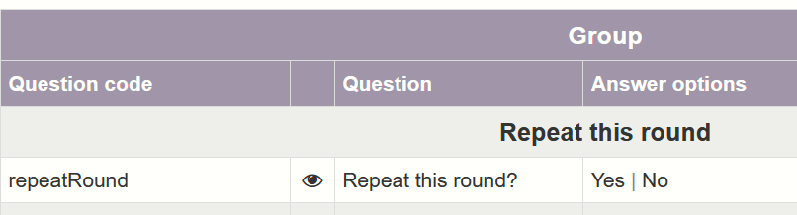The survey that determines the repetition has to have a Yes/No Question with the question code repeatRound. Yes (i.e. the value Y) means the round must be repeated.

There are two method available for setting the period the new tokens will be valid: in a single dropdown or using separate fields for the length of the repetition and the unit to be used.

### Single field dropdown

When using a single drop down the question code must be repeatUnitCount, the options must then have the format {letter}{integer}, where the letter is one of N, H, D, W, M, Q, Y, specifying the period is miNute, Hour, Day, Week, Month, Quarter or Year. The integer specifies the number of periods. H12 is twelve hours. W2 is 14 days.

You can also use the LimeSurvey option for another manually specified value (that gets the question code repeatUnitCountother) to allow the user to specify a number, but this will always be interpreted as a number of days.

An example survey is included on GitHub: Repeat_round_dropdown_survey_365161.lss.

### Multi field period

The alternative method is to use a single number field with question code repeatRound to specify the number of periods and repeatUnit to specify the letter the determines period.

An example survey is included on GitHub: Repeat_round_multi_field_survey_365161.lss

### Other survey settings

Of course, you need not specify the “valid for” period or have the question answered by the user. It can just be a hidden question specifying a fixed period. You can make multiple surveys for different periods or different period choices. Only to make it work you dop have to set the “After completion” event under Track builder -> Surveys -> Edit:



After setting the “After completion” event you can use the “Check is answered” button to apply the setting to already answered instance of the survey. I.e. the rounds will then be repeated.

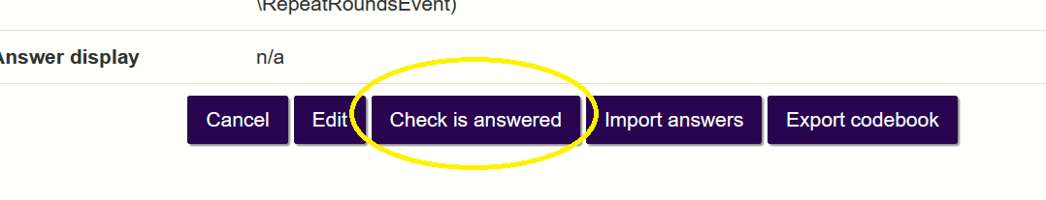

## Preparing the track

On the right we see an extremely simple example track using the repeat function.

The first round has a different description than the other two. This means that survey will not be repeated.

The only requirements for the rounds to be repeated is:

1. All rounds have to have the same description.
2. This description should end with a number.
3. The repeat survey is the last survey with the description.

The description does not have to end with the number 1, another number is fine. The event function will just add one to that number. I.e. “Test round Q2” becomes “Test round Q3”.

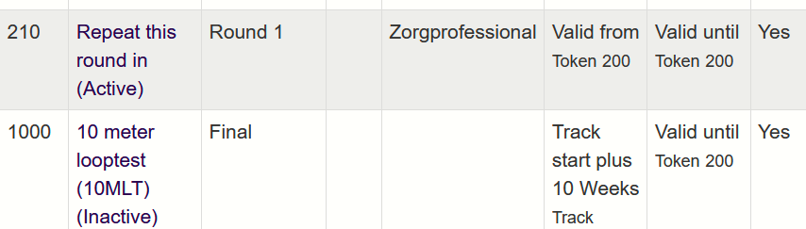Again this is to keep things simple as this suffices for the current use case.

**Notice** that this does not say it has to be **the last round!** Only the last round with that description! You can add later rounds with a different description.

**However!** Do give this round a significantly higher order! The reason the repeat question must be the last is that when repeating surveys the user track internally uses round numbers by adding 1 to every round that is repeated. Thus the original survey 200 will get an internal round number 211 (210 + 1) while the repeat of the final survey will get the number 212. For “Ronde 3” these will be numbers 213 and 214.

If the new internal round number already exists, then the new round will not be created and thus the repetition will break down. This is also the reason the question must be asked in the last survey.

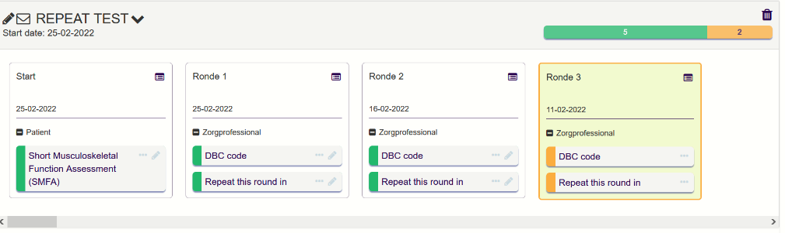The internal round numbers do not have an effect otherwise, so this is the track after two repetitions.